User Guide
This user guide explains how to use the AI-powered Regulatory Compliance Management System. It provides step-by-step instructions for accessing the system and using its main features.
1.Assessing the system
Step 1: Open your web browser and navigate to:
- Local: http://localhost:3000
- Live : https://automated-regulatory-and-compliance-bjn0.onrender.com

Step 2: You will see the login screen.
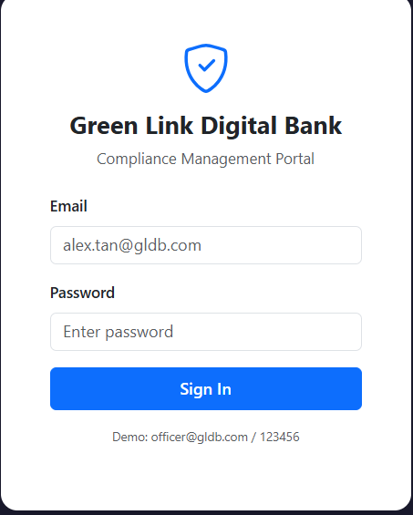

Step 3: Enter your credentials:
Role | Email | Password
Compliance Officer | officer@gldb.com | 123456

Step 4: Click “Sign In”. You will be taken to the Home Page.
2. Home Page
The home page shows a quick overview:
- Unread Alerts count
- Open Gaps count
- Pending Tasks count
To return to the home page at any time, click the GLDB logo in the top navigation bar.
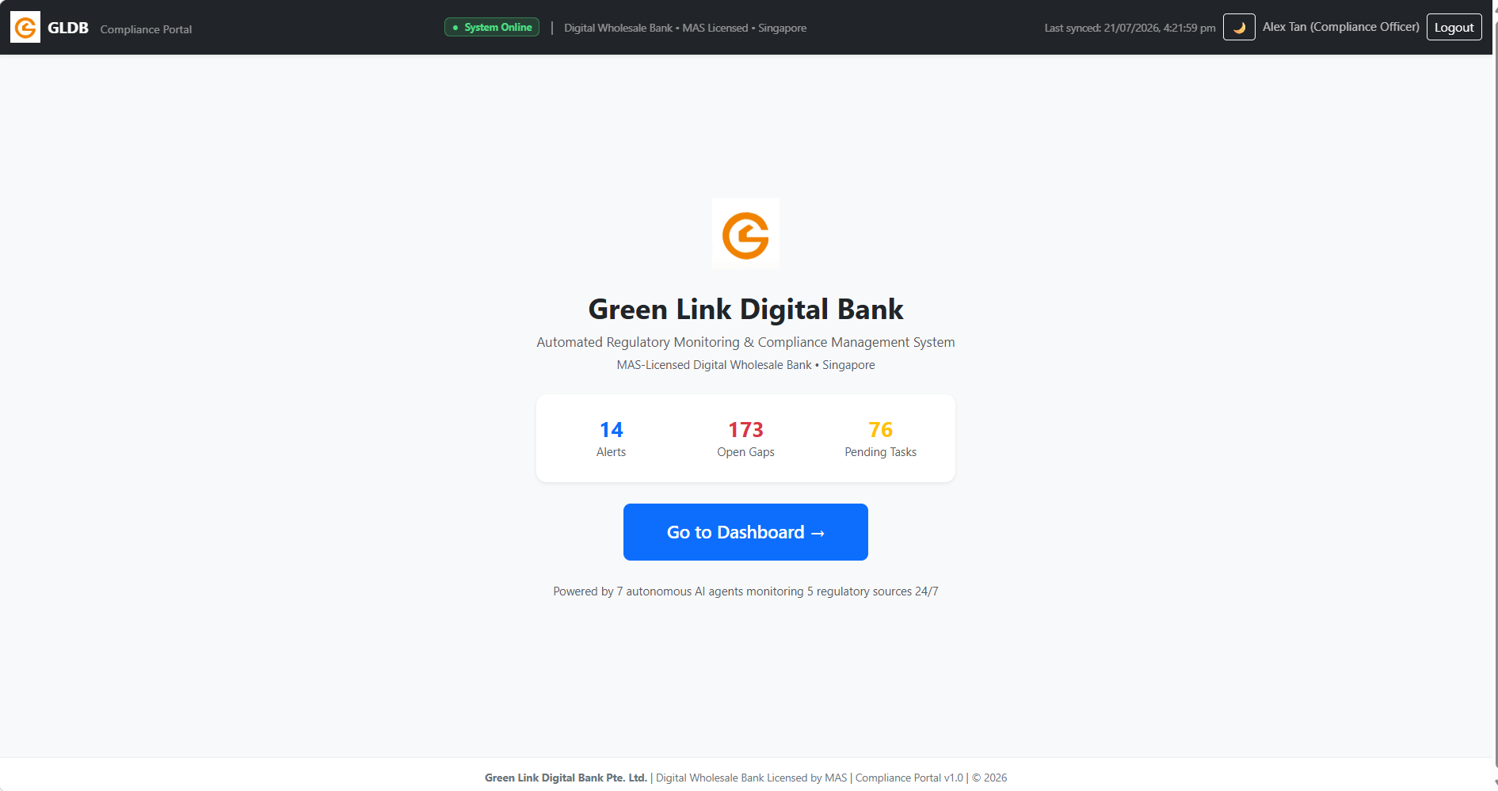

Click “Go to Dashboard” to enter the full compliance dashboard.
3. Navigating the Dashboard
The dashboard has a sidebar with 9 tabs. Click any tab to switch views.
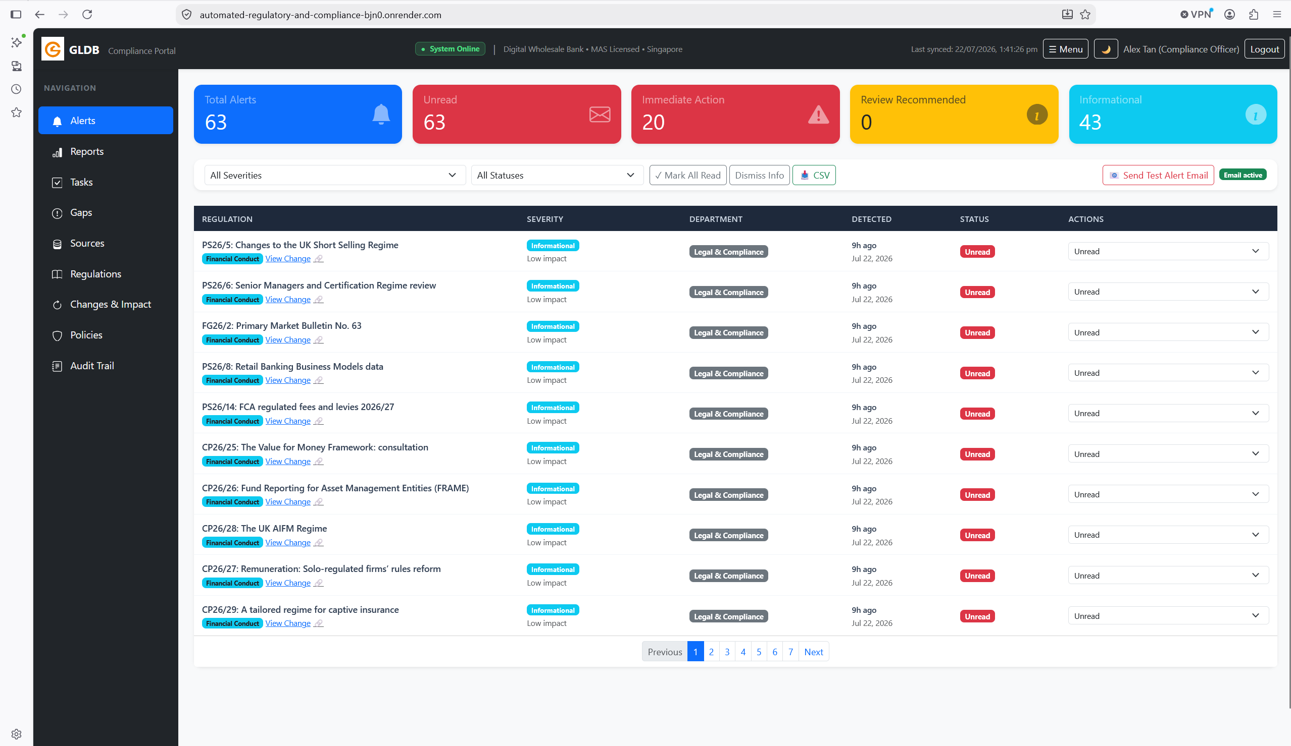
To hide the sidebar for full-width content, click the "☰ Menu" button in the top-right corner. Click again to show it.
To enable Dark Mode, click the 🌙 button in the top-right corner.

4. Alert Tab
Viewing Alerts
Step 1: Click "Alerts" in the sidebar.
Step 2: Review the 5 summary cards at the top showing alert counts by severity.

<<Put Screenshot of Alerts Tab with Summary Cards>>
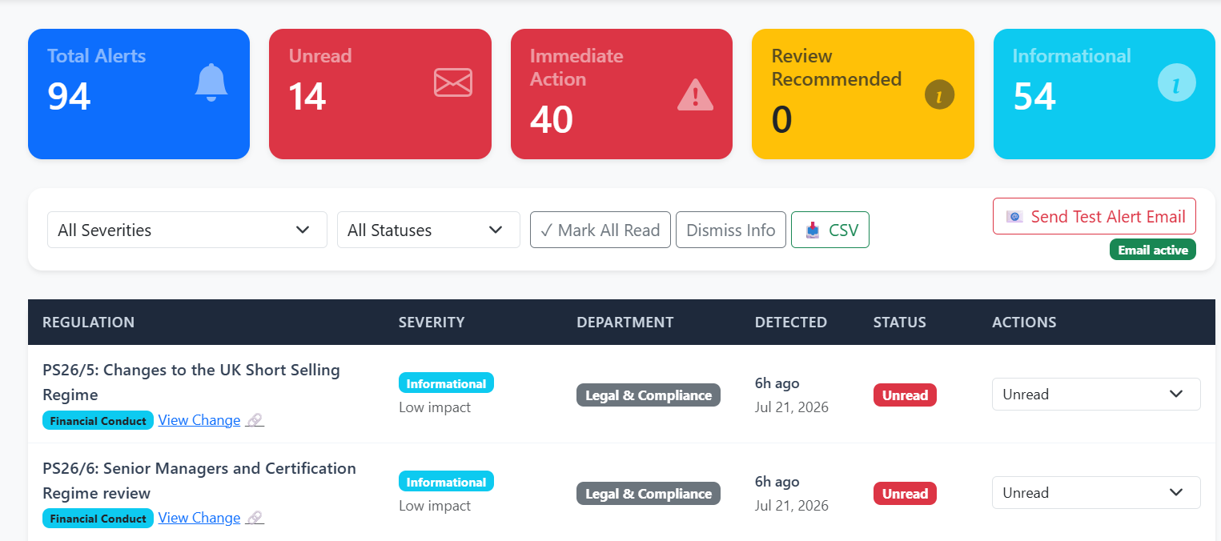
Filtering Alerts
Step 3: Use the severity and status dropdowns to filter alerts.

Bulk Actions
Step 4: Click "✓ Mark All Read" to mark all alerts as read, or "Dismiss Info" to dismiss all Informational alerts.

Investigating an Alert
Step 5: Click "View Change" on any alert to navigate directly to the Changes & Impact detail for that regulatory change.

Sending Email Digest
Step 6: Click "📧 Send Test Alert Email" to send a summary digest email to the configured Gmail address.

<<Put Screenshot of Email Received in Gmail>>
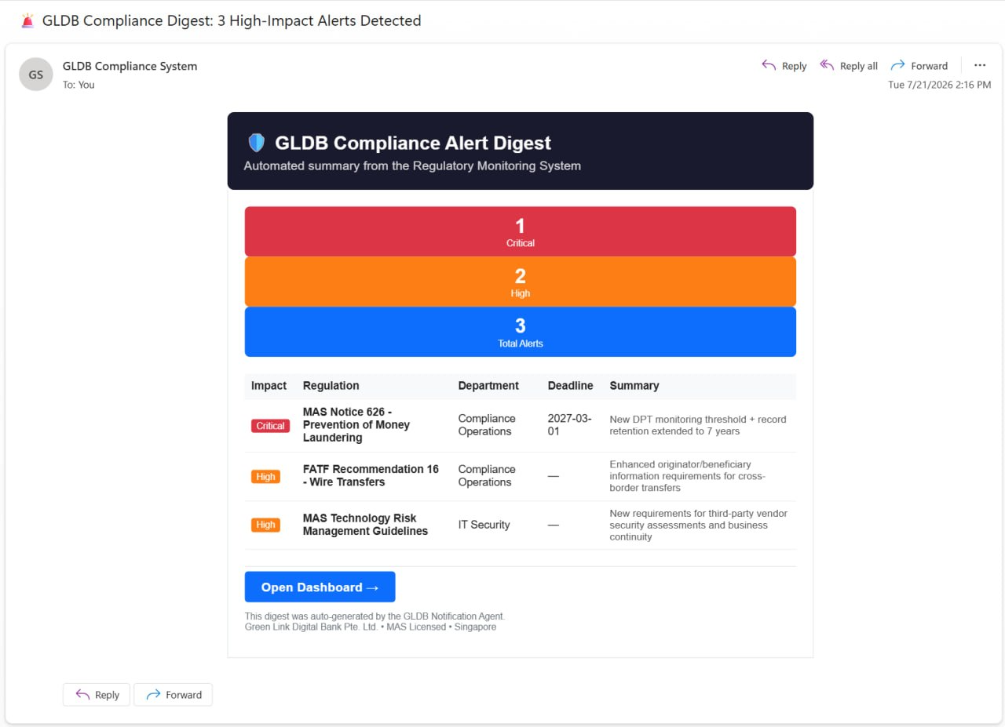

5.Changes & Impact Tab
Viewing Regulatory Changes
Step 1: Click "Changes & Impact" in the sidebar.
Step 2: Review summary cards: Total Changes, Critical, High, Medium, Auto-Tasks Created.

<<Put Screenshot of Changes & Impact Tab>>
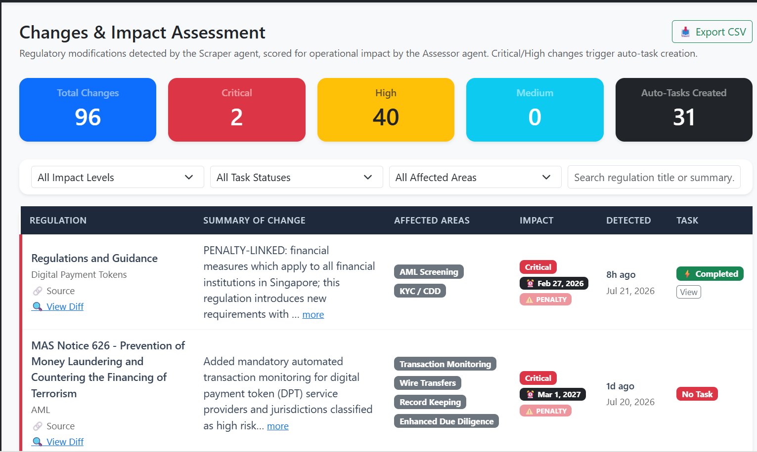
Filtering
Step 3: Use the 4 filters: Impact Level, Task Status, Affected Areas, and Search.

Viewing a Diff (Old vs New Comparison)
Step 4: Click "🔍 View Diff" on a regulation change that has both old and new versions.
Step 5: The detail panel opens showing:

- Previous Version (left panel, red border)
- Current Version (right panel, green border)
- Change summary, affected areas, compliance deadline

<<Put Screenshot of View Diff Panel showing Old vs New>>
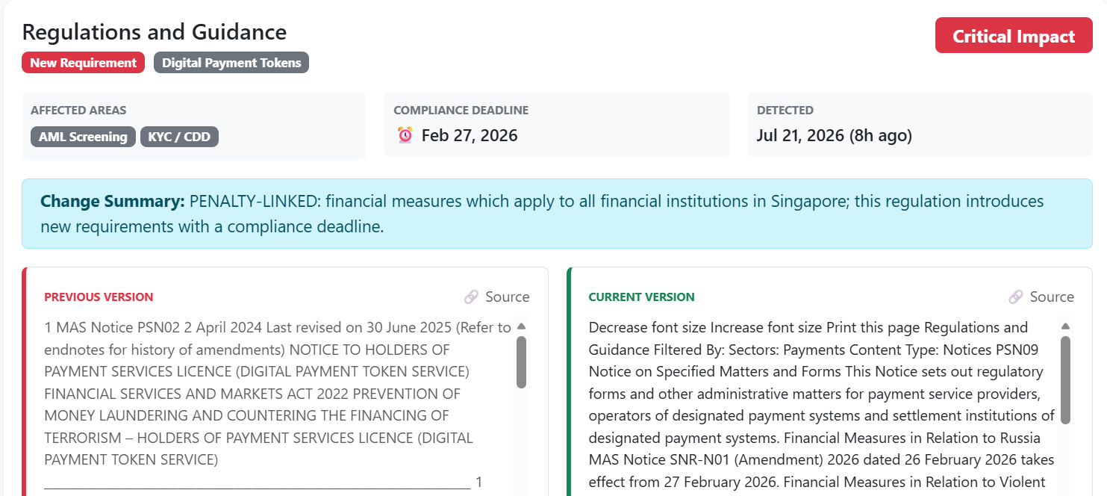
Penalty-Linked Changes
Changes with penalties show a pulsing ⚠️ PENALTY badge and are always sorted first.
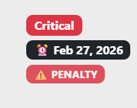
6.Tasks Tab
Viewing Tasks
Step 1: Click "Tasks" in the sidebar.
Step 2: Review auto-generated tasks. Each task shows:
- Title and department
- Clickable 🔗 N gaps badge → navigates to linked gaps
- Clickable 📋 N changes badge → navigates to linked regulatory changes

<<Put Screenshot of Tasks Tab with Linkage Badges>>
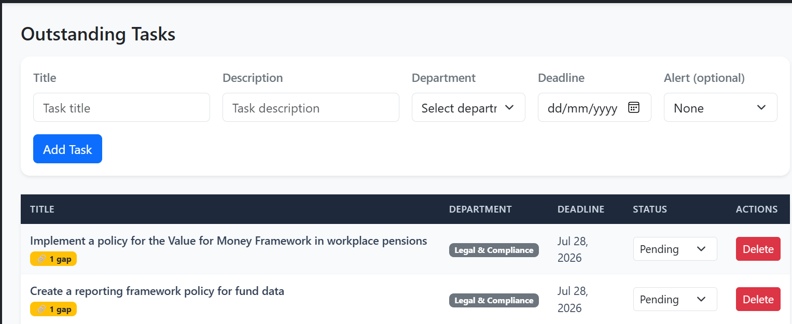
Updating Task Status
Step 3: Change the status dropdown: Pending → In Progress → Completed.
Note: Marking a task as "Completed" automatically sets all linked compliance gaps to "Remediated".
Creating a Manual Task
Step 4: Fill in the task form (Title, Department, Deadline) and click "Add Task".
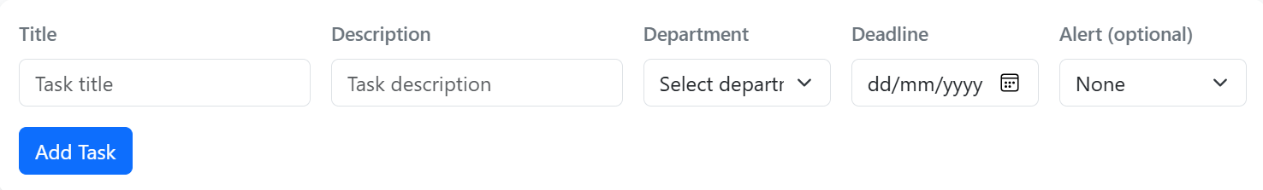
7.Compliance Gaps Tab
Viewing Gaps
Step 1: Click "Gaps" in the sidebar.
Step 2: Review the progress bar and summary cards (Open, In Review, Remediated).

<<Put Screenshot of Gaps Tab with Progress Bar>>
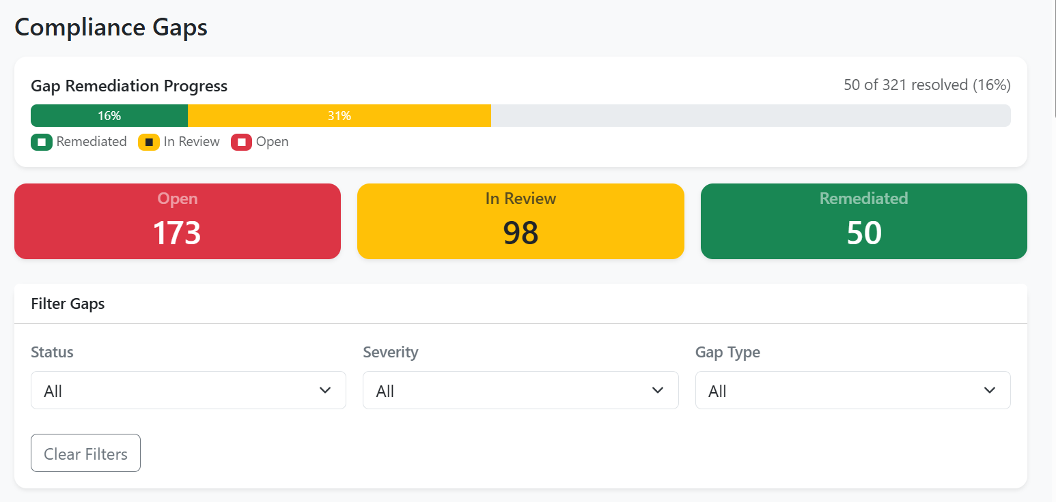
Filtering Gaps
Step 3: Filter by: Status, Severity, and Gap Type (5 types: Missing Procedure, Outdated Procedure, Insufficient Detail, Missing Control, Non-Compliant Threshold).

Creating a Task from a Gap
Step 4: Click "Create Task" on any gap.
Step 5: Fill in the modal form (Title, Description, Department, Deadline) and click "Create Task".
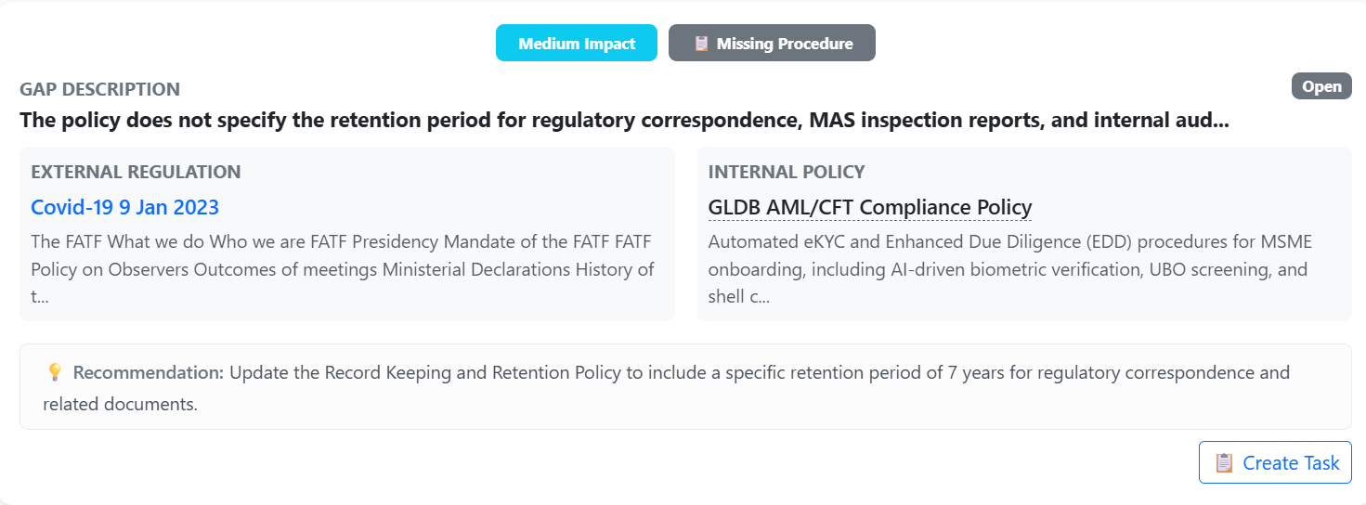
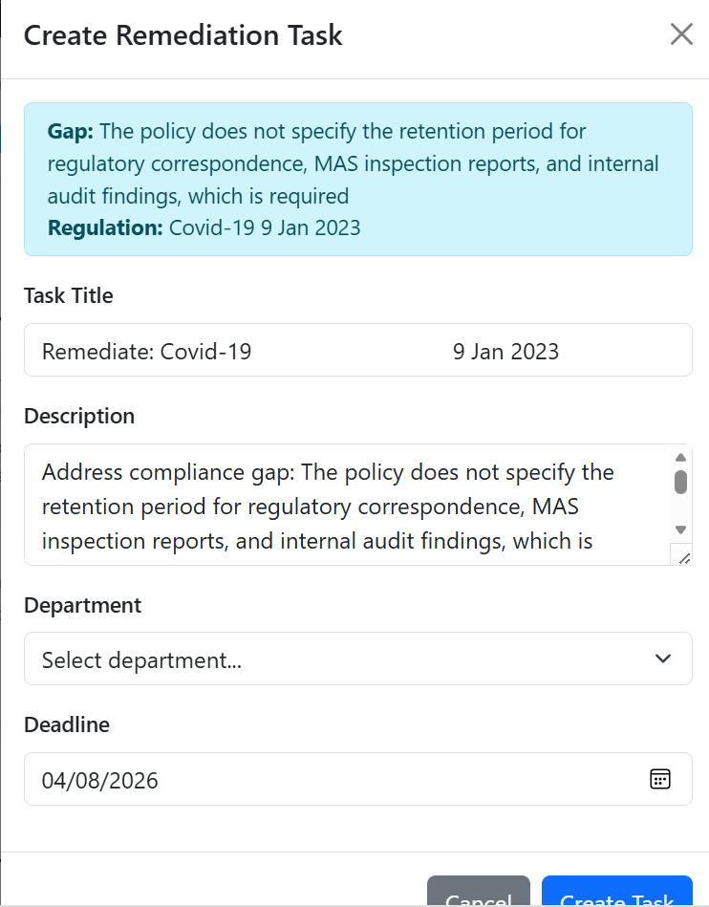
<<Put Screenshot of Create Task Modal>>
8.Regulations Knowledge Base Tab
Viewing Regulations
Step 1: Click "Regulations" in the sidebar.
Step 2: Browse all scraped regulations. Click the regulation title to open the official source in a new tab.

<<Put Screenshot of Regulations Tab>>
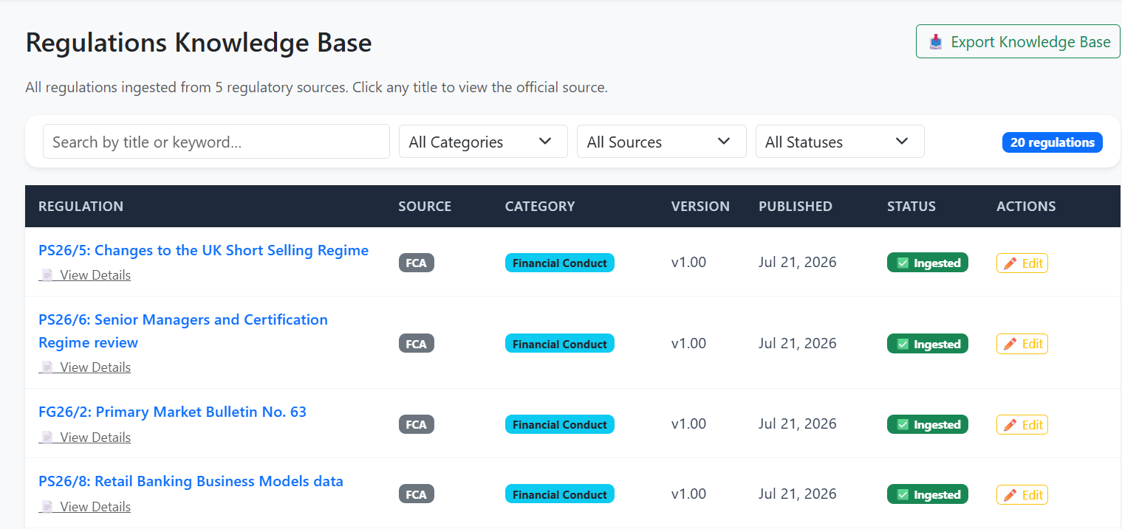
Viewing Regulation Details
Step 3: Click "📄 View Details" to open the detail panel showing full content, related changes, and related gaps.

Uploading a PDF Regulation
Step 4: In the "📄 Upload PDF Regulation” section:
- Enter a title (optional — auto-detects from filename)
- Select a category
- Select a source
- Choose the PDF file
- Click "📤 Upload & Process"

<<Put Screenshot of PDF Upload Form>>

Step 5: The system extracts text detects if it's an update to an existing regulation and triggers the full AI pipeline.

<<Put Screenshot of Upload Success Message>>

Scraping a URL

Step 6: In the "🔗 Scrape from URL" section:
- Paste the regulatory page URL
- Enter title (optional)
- Select category and source
- Click "🔍 Scrape & Process"
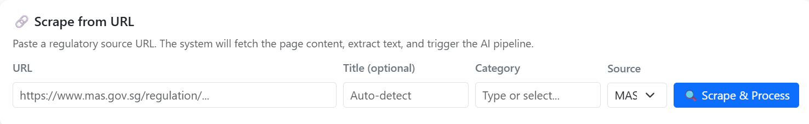
The system uses a headless browser to render JavaScript-heavy pages.

9.Policies Tab
Viewing Policies
Step 1: Click "Policies" in the sidebar.
Step 2: Policies are displayed as cards. Click "📋 View Procedures" to expand the step-by-step procedures.
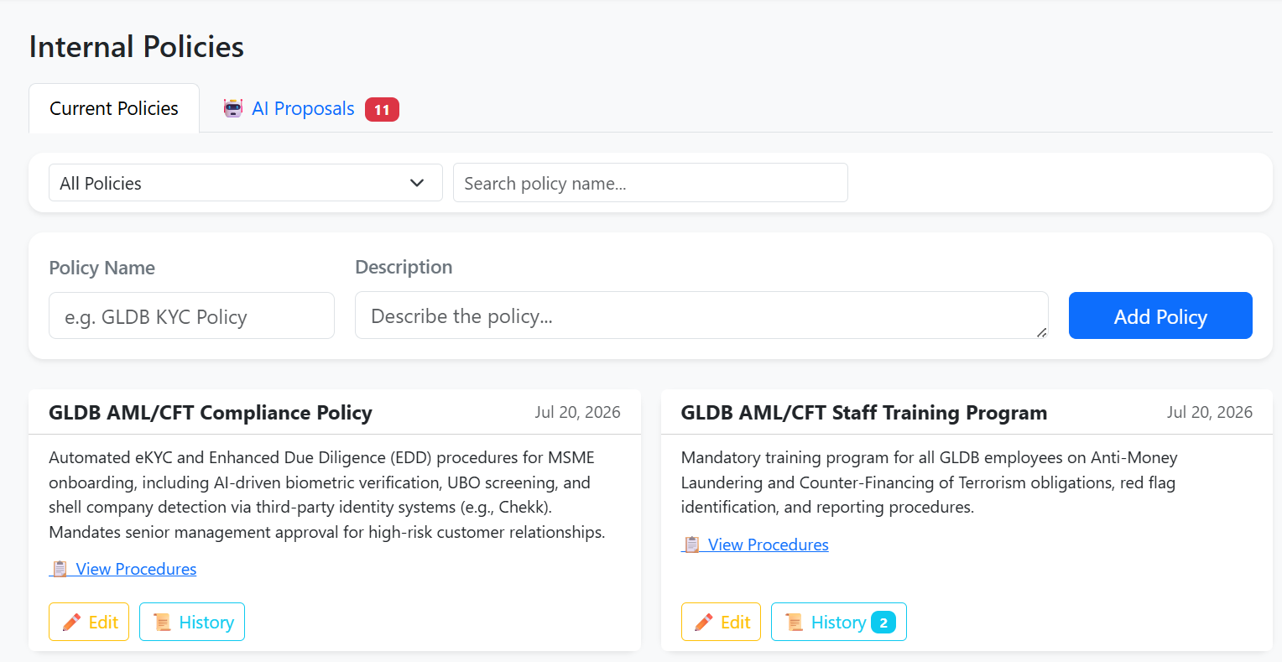
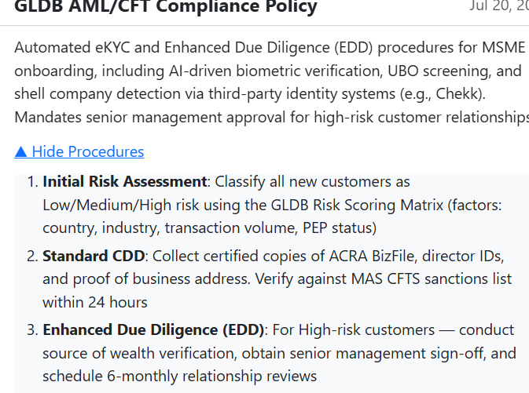
<<Put Screenshot of Policy Card with Expanded Procedures>>
Filtering Policies
Step 3: Use the filter dropdown: All Policies, Has Version History, No History, 🤖 AI Generated.

Reviewing AI Proposals
Step 4: Click the "🤖 AI Proposals" sub-tab.
Step 5: Review the proposed policy text, procedures, and AI reasoning.
Step 6: Click "✅ Accept & Apply" to apply the policy, or "❌ Reject" to discard.

<<Put Screenshot of AI Proposal Card>>
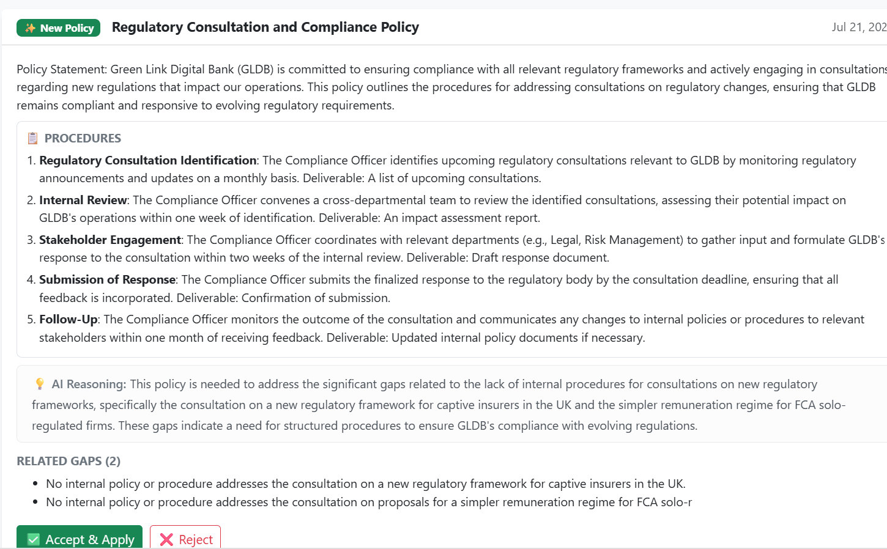

Viewing Policy History
Step 7: Click "📜 History" on any policy to see all previous versions.

10.Reports & Analysis Tab
Step 1: Click "Reports" in the sidebar.
Step 2: Navigate between 4 sub-tabs:
- Regulatory Changes — impact distribution, category bar, changes timeline
- Gap Analysis— gap type pie, gaps by policy, resolution rate
- Tasks & Remediation— task status, department workload, deadline burndown
- Compliance Posture — overall score %, policy coverage heatmap

<<Put Screenshot of Reports Tab - Compliance Posture>>
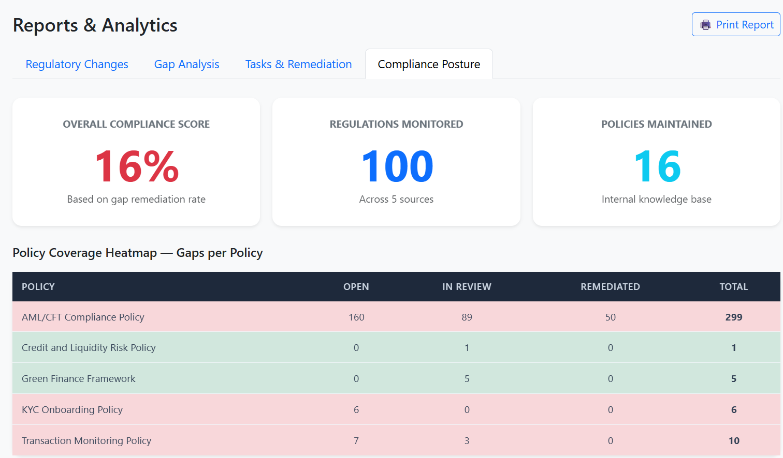

Printing a Report
Step 3: Click "🖨️ Print Report" to generate a formatted printable report.

11.Audit Trail Tab
Viewing the Audit Trail
Step 1: Click "Audit Trail" in the sidebar.
Step 2: Review summary cards: Total Actions, This Week, 🤖 AI Agent Actions, 👤 Human Actions.

<<Put Screenshot of Audit Trail with Summary Cards>>
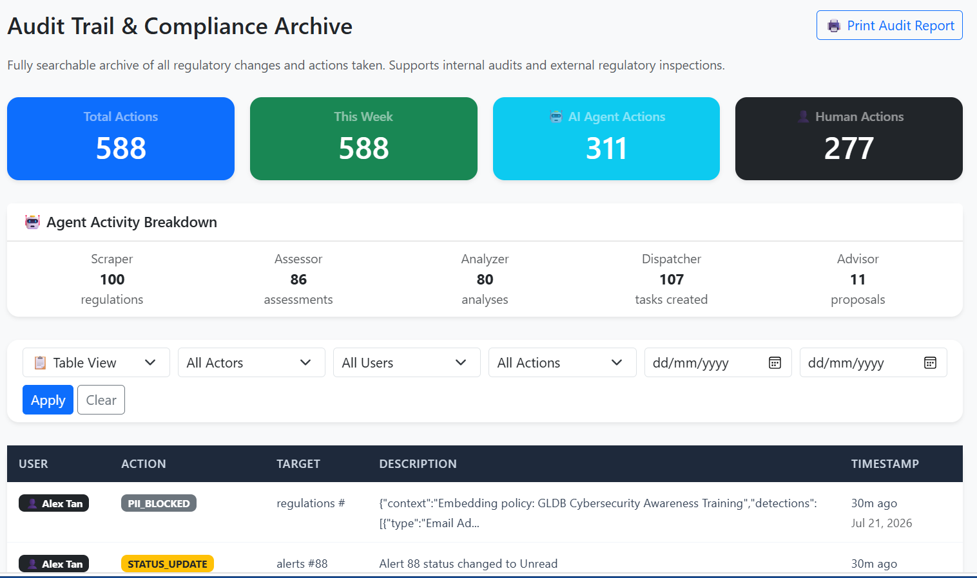

Switching Views
Step 3: Use the view mode dropdown:
- 📋 Table View — traditional table format
- ⏱️ Timeline View— chronological feed with icons
- 🔗 Response Chain— select a regulation to see its full compliance lifecycle

<<Put Screenshot of Response Chain View>>
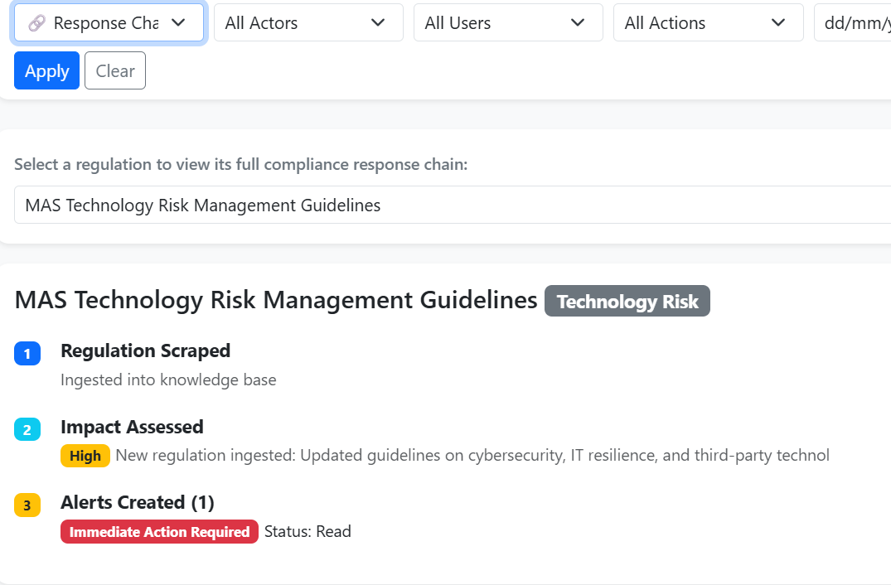
Filtering by Actor
Step 4: Use the "All Actors" dropdown to filter: 🤖 AI Agent Only or 👤 Human Only.

Printing Audit Report
Step 5: Click "🖨️ Print Audit Report" to generate a formatted audit document for regulatory inspections.

12.Sources Tab
Step 1: Click "Sources" in the sidebar.
Step 2: View the 5 regulatory sources (MAS, FATF, FinCEN, ECB, FCA).
Step 3: To add a new source, fill in the name and URL and click "Add Source".
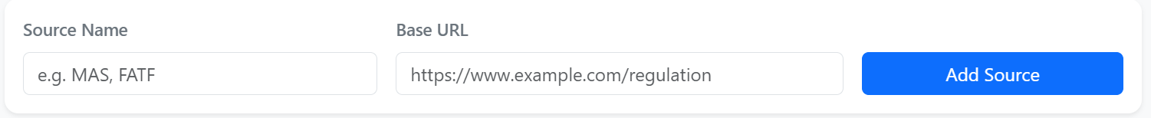
13.Logging Out
Step 1: Click "Logout" in the top-right corner to end your session and return to the login screen.

